Assignment # 5
Programming Assignment
Date assigned: 9/22/2014
Date due: 9/29/2014
- Write a program (with explanatory comments) to generate a random graph (simple) of order n and density ρ (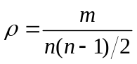). Test it with 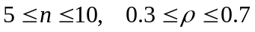. Submit the program listing, generated graphs (adjacency matrix & sketch) and your observation.

- Write a program to compute the degree sequence of a given graph (sorted non-increasing order). Submit the output.

Deliverables: Program source, generated graph and sketch, and also a brief summary of your observation. You can write your program in any language you like, but you should include a text file explaining how to compile and run your program. You should e-mail the deliverables to the TA by 9/29/2014 midnight.

